General Welfare Requirement: Safeguarding and Promoting Children's Welfare
The provider must promote the good health of the children, take necessary steps to prevent the spread of infection, and take appropriate action when they are ill.
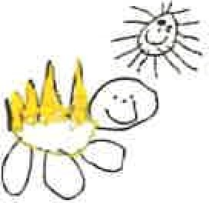
Gorran Pre School
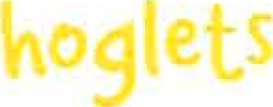

Promoting health and hygiene
1.18 No-smoking
Policy statement
At Gorran Pre-School Hoglets we comply with health and safety regulations and the Welfare Requirements of the EYFS in making our setting a no-smoking environment - both indoor and outdoor,
EYFS key themes and commitments
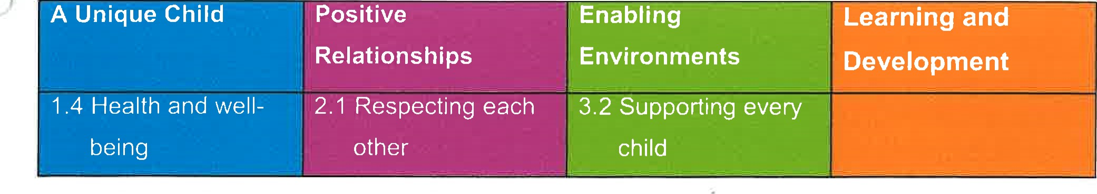
Procedures
- All staff, parents and volunteers are made aware of our no-smoking policy. We display no-smoking signs.
- The no-smoking policy is stated in our information brochure for parents.
- We actively encourage no-smoking by having information for parents and staff about where to get help to stop smoking if they are seeking this information.
Staff who smoke do not do so during working hours. Unless on a break and off the premises.
Staff who smoke during their break make every effort to reduce the effect of the odour and lingering effects of passive smoking for children and colleagues.
Legal framework
The Smoke-free (Premises and Enforcement) Regulations 2006 www.opsi.gov.uWsi/si2006/20063368.htm The Smoke-free (Signs) Regulations 2007 www.opsi.gov.uWsi/si2007/20070923.htm

This policy was adopted at a meeting of
Held on October 2019
Date to be reviewed October 2020
Name of signatory
Role of signatory (Manager)

Michelle Beard

Pre-School Leader/Nominated Person

